Lab 7 - Activity 2: Packet Tracer – Configure PPP with CHAP

Student No:c18322011 Name: Omair Duadu

This activity allows you to test your PPP and CHAP configuration skills. Refer to your lab notes and previous NetAcad content if you need assistance. Do not copy configuration commands from the Internet as they may not suit the current configuration context. Always refer to NetAcad content for information in the first instance.

**Provide screen shots where indicated**.

1. Topology

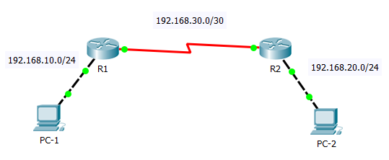

1. Addressing Table

|  |  |  |  |  |
| --- | --- | --- | --- | --- |
| Device | Interface | IPv4 Address | Subnet Mask | Default Gateway |
| R1 | G0/0 | 192.168.10.1 | 255.255.255.0 | N/A |
| S0/0/0 | 192.168.30.1 | 255.255.255.252 | N/A |
| R2 | G/0/0 | 192.168.20.1 | 255.255.255.0 | N/A |
| S0/0/0 | 192.168.30.2 | 255.255.255.252 | N/A |
| PC-1 | NIC | 192.168.10.2 | 255.255.255.0 | 192.168.10.1 |
| PC-2 | NIC | 192.168.20.2 | 255.255.255.0 | 192.168.20.1 |

1. Scenario

Configure PPP encapsulation on R1 and R2’s Serial Interfaces and enable and CHAP authentication. Test connectivity between PC-1 and PC-2. You do not need to configure IP addresses on the PCs or the Routers. This has been already done.

Requirements

**Check the current serial encapsulation on both Routers**What command will you use? show interface serial 0/0/0

* **R1** serial encapsulation = HDLC
* **R2** serial encapsulation = HDLC

**PPP**

* Configure PPP encapsulation **R1** serial interface
* Configure PPP encapsulation **R2** serial interface
* Verify PPP encapsulation on **R1** and **R2**

**CHAP**

* Configure CHAP Authentication on **R1**
  1. Use **cisco** as the password on both Routers
  2. What **username** should be used on R1? Router A
* Configure CHAP Authentication on **R2**
  1. Use **cisco** as the password on both Routers
  2. What **username** should be used on R2? RouterB
* Verify CHAP configuration on **R1** and **R2**

**Verify Connectivity**

* Ping from PC-1 to PC-2. Use ping from PC-1 command line.

Take a screen shot of the **ping output** on PC-1 command line and paste it in below.

Screen shot:

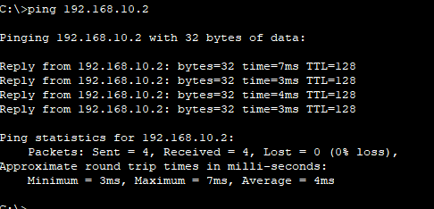

**Record the PPP and CHAP configurations for R1 and R2 for reference below**.

**R1 PPP and CHAP**

RouterA(config)#interface Serial 0/0/0  
RouterA(config-if)#ip address 10.0.1.1 255.255.255.0  
RouterA(config-if)#encapsulation PPP  
RouterA(config-if)#bandwidth 512  
RouterA(config-if)#clockrate 64000  
RouterA(config-if)#no shutdown

RouterA(config)#hostname RouterA  
RouterA(config)#username RouterB password C1sco123  
RouterA(config)#interface Serial 0/0/0  
RouterA(config-if)#ip address 10.0.1.1 255.255.255.0  
RouterA(config-if)#encapsulation ppp  
RouterA(config-if)#ppp authentication chap

**R2 PPP and CHAP**

RouterB(config)#interface Serial 0/0/0SSS

RouterB(config-if)#ip address 10.0.1.2 255.255.255.0

RouterB(config-if)#encapsulation PPP

RouterB(config-if)#bandwidth 512

RouterB(config-if)#no shutdown

RouterB(config)#hostname RouterB  
RouterB(config)#username RouterA password C1sco123  
RouterB(config)#interface Serial 0/0/0  
RouterB(config-if)#ip address 10.0.1.2 255.255.255.0  
RouterB(config-if)#encapsulation ppp  
RouterB(config-if)#ppp authentication chap